The Bitcoin Diaspora

A Confederation of Tribes

By Joe Rodgers

INSERT DATE HERE

[**“There is no Bitcoin community” - Everyone**](https://twitter.com/search?q=%22no%20bitcoin%20community%22&src=typed_query)

This is the battle cry of true-believers and deniers alike. There is no CEO, PR, or speaker for Bitcoin. Bitcoin is decentralized, so there is none of that. So why do people get triggered so easily when people utter the phrase “Bitcoin community”?

Surely there is something, but what is it?

During Bitcoin’s short existence, it has grown from a small cypherpunk email list to a globally traded money with a $100B+ market cap. How can something like this happen with no “Bitcoin community”.

Surprisingly, there is “no Bitcoin community” but there is a Bitcoin diaspora, a confederation of tribes.

To fully understand this social phenomenon, we must have a basic understanding of these concepts: **diaspora, specialization, and confederation**. This will surely not satisfy all critics, but the aim is to present a mental model we can use when describing all individuals and communities that use Bitcoin.

**What is a Diaspora**

A quick search on the internet will yield many different definitions for diaspora. Traditionally, the word has been reserved for describing the dispersion of Jews beyond Israel but it is now more commonly used to describe the scattering of people away from their homeland.

While traditional diasporas have been rooted in the physical world, the Bitcoin diaspora is rooted in the digital world. Over time, we are witnessing the transformation of the Bitcoin diaspora into a hybrid of physical and digital worlds.

From the beginning of Bitcoin’s creation, users were geographically scattered, but shared a common digital home via the Cryptography Mailing List. This mailing list was home of the first Bitcoin users. Over time these users spread the good word of Bitcoin to other digital domains.

Eventually users from different digital communities organized in a manner to further connect in the physical world via meetups, conferences, and even citadels. Once Bitcoin users made the jump to connect in the physical world, the Bitcoin diaspora transformed from being a digital to a hybrid diaspora. This is a special characteristic of this organic social phenomenon.

**About Specialization**

Once the diaspora branched out beyond the cryptography mailing list, Bitcoin was exposed to people with different areas of expertise. Since Bitcoin is decentralized, people are free to share and sharpen ideas as they please. What has happened over the past decade is an impressive example of specialization.

Once a person with domain knowledge got their mind on Bitcoin, they tended to see the world through a new lens, and this outcome was specialization.

[*“I believe that Bitcoin is a mirror - it reflects who you are; it reflects your beliefs.” Gigi*](https://bitcoinwords.github.io/tweetstorm-circularity)

Domain experts began crafting ideas and narratives around Bitcoin. This specialization of ideas has led to the emergence of various Bitcoin disciplines.

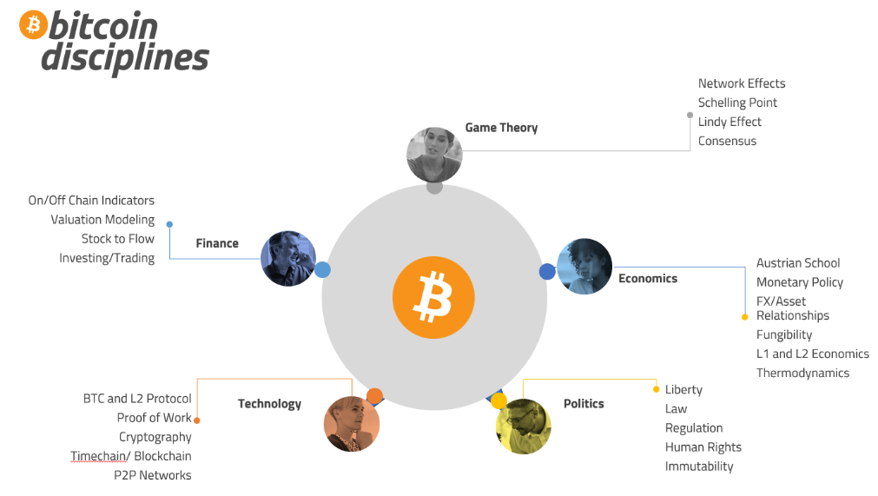

These disciplines look familiar at first glance, but once you dig into the writings, code, and other products created from these disciplines, you will find that Bitcoin is changing us far more than we are changing it.

**Confederation**

Human organization is a part of natural social order. Through the scattered diaspora and specialization, the Bitcoin diaspora has spawned many tribes that share ideas, norms, and values.

**

As you dig a little deeper into this social phenomenon, you will see that these tribes form a confederation. The term confederation, like all things, has many meanings. We are defining confederation as a number of parties united in alliance. What’s important about that definition is what makes the Bitcoin confederation united in alliance. All the tribes of the Bitcoin diaspora have one thing in common, it’s members [want more Bitcoin](https://bitcointalk.org/index.php?topic=5215927.0). Everyone in the Bitcoin diaspora want more Bitcoin.

Tribes are in competition with each other but are still developing specialization that benefits the other tribes. This is a beautiful consequence of competition and cooperation.

**Conclusion**

As the Bitcoin diaspora continues to spread, so too will it’s ideas sharpen. The tribes will grow and splinter and refocus. Specialization will lead to a new revolution for humanity.

This is inevitable. Like a blackhole, Bitcoin sucks in everything of value within its reach. So too will the Bitcoin diaspora capture the hearts and minds of humanity’s best.

**The Bitcoin diaspora will take us to the stars and beyond.**